The Algebra of Functions Section 1.8

Perform Operations on Functions

provided that g(x) ≠ 0

Given , , , evaluate the function, if possible.

1. 2. 3.

4. 5.

6. 7.

Evaluate and write the domain in interval notation.

8. 9.

10.

Evaluate a Difference Quotient
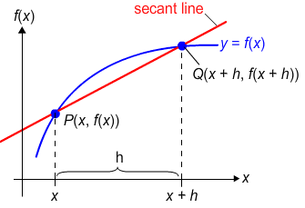
The average rate of change between P and Q is the slope of the secant line and is given by:

The expression is called the difference quotient.

11. Find and for .

12. Find and for .

Compose and Decompose Functions

The composition of f and g, denoted is defined by .

13. Given and , find

14. Given and , find

15. Given and , find

16. Given and find and the domain of .

17. Given find two functions f and g such that .

18. Given find two functions f and g such that .

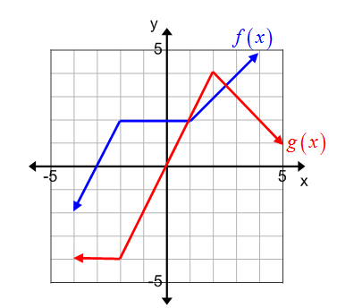
19. Estimate the function values from the graph.

a.

b.

c.

d. e.

20. A party balloon is being filled with helium. As the balloon is filling, the radius of the balloon is changing at the rate of 3 inches per second.

a. Write a function that represents the radius of the balloon r(t) after t seconds.

b. Write a function that expresses the volume of the balloon V (r) as a function of its radius r.

c. Evaluate and interpret the meaning in the context of this problem.

d. Evaluate and interpret the meaning in the context of this problem.

